Additional RNN Lecture 6 CSE5ML Information

RECURRENT NEURAL NETWORKS

**Questions that RNNs can answer**

1. **Performing text analysis using neural networks**

Think of a string of text as streaming in overtime; regardless of how many words you see in a given document, you want to make as good an estimate as possible about whatever outcome is of interest.

1. **Addressing inputs of different lengths**

The key feature of an RNN is that part of the network’s state is fed back in as input. This gives the RNN a form of persistent memory about past inputs.

1. **Working with time-series data**

Because each simulated iteration of the RNN will combine a ‘running memory of the past’ with the latest input, a past of arbitrary length can be incorporated as context in interpreting the current input. Because the ‘memory of the past’ is cumulative and is not hard-coded to be a particular length, that memory can handle pasts of variable length as well — that is, time-series data.

When you have a picture, the pixels are the fixed lengths. These metrics fix the dimension of training samples. However, the input length is not fixed for time-series data training and is somewhat different.

1. **Mapping input sequences to output sequences with possible different lengths**

For example, in a translation from Chinese to English, the input to this RNN is called the context and the goal is to find a representation of the context C. In this case, C could be a vector or a sequence that summarises, where X = {x(1), ..., x(n)}.

When working with RNNs, you need to look at the problem from different angles and think of variability in input width. Each new word updates our current prediction. In other words, we can think of an RNN as an algorithm that gives memory to the neural network.

RNNs have two different data types:

1. fixed weight inputs: our usual neural networks
2. state variables: updated as words are observed in a document.

##### Mathematically speaking

RNN is an abstract concept that requires a model and mathematical equations to provide an understanding of it. Mathematically speaking, the input–output relation of a standard neural network is altered to feed the output into the input. Consequently, we now have two parts to the update function in the RNN, as shown below.

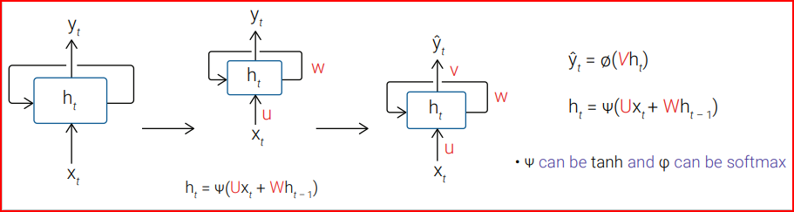

## **Unrolling RNN**

RNNs can be seen as a traditional feedforward neural network by unrolling the time component; it is the relationship between time and samples. We typically restart the state, or memory, of the RNN when we move on to a new sample.

**Activity: Recurrent neural networks**

Answer the following questions on recurrent neural networks. When you are finished, check your answers against the solutions provided below.

1. What are recurrent neural networks?
2. Please indicate the shared parameter in the following figure.

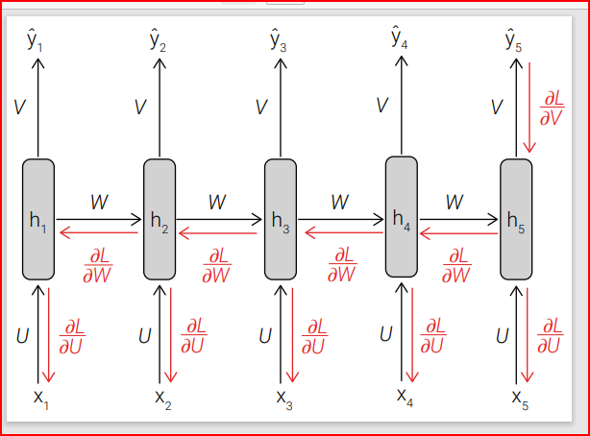

1. What are the applications of recurrent neural networks?

## Solution

1. Recurrent neural networks are a type of neural network in which the output of previous time slices is fed as input to the current time slice.
2. W, V and U.
3. Speech recognition, image captioning, stock price prediction etc.

##### Shared parameters

As the weights are shared across different timestamps, how can we guarantee the enforcement of such constraints? The answer is simple: We train the RNN by obtaining weights at different time stamps, and then we compute their average as if there were no constraints.

## **Bi-directional RNN**

Bi-directional RNNs are just putting two independent RNNs together. The input sequence is fed in normal time order for one network, and in reverse time order for another. The outputs of the two networks are usually concatenated at each time step, though there are other options — for example, summation. This structure allows the networks to have both backward and forward information about the sequence at every time step. A diagram of a mathematical equation

Taking into account what we have learnt above, we can say that RNNs state a time to capture information from the past x(1), . . . , x(t − 1), but what if we are interested in an output y(t) that may depend on the whole input sequence?

One example, in this case, would be when the interpretation of a current sound as a phoneme may depend on the next few (co-articulation). Bi-directional RNNs were introduced in response to this need by Schuster and Paliwal in 1997 and have been used in many fields, including handwriting recognition, speech recognition (2005) and bioinformatics.

**LONG SHORT-TERM MEMORY**

In this topic, we will explore RNN and long short-term memory (LSTM) using the IMDb movie review dataset. You will learn about simple RNN, and LSTM networks and modules.

##### Reflection

Convolutional neural network (CNN) and long short-term memory (LSTM) are the most demanding types of artificial neural networks used in the fields of artificial intelligence and deep learning.

The basic idea of a long short-term memory (LSTM) is the same as a simple RNN. However, the internal layers are more complex. This type of recurrent neural network was created in 1997 by Hochreiter and Schmidhuber to solve the limitations of RNNs by having the capability of learning long-term dependencies, including two self-loops and several independent weight functions.

